What is mean by Web Application?
Any application which is accessed by web is called web application.
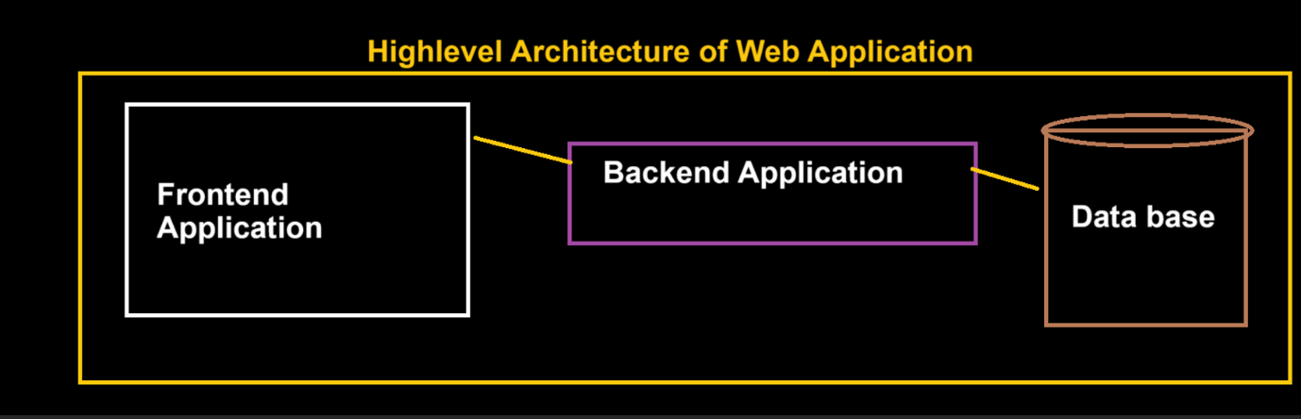
FRONT END APP or client-side App.
BACK-END APP or Server-side App.
DATABASE
Types Of applications:
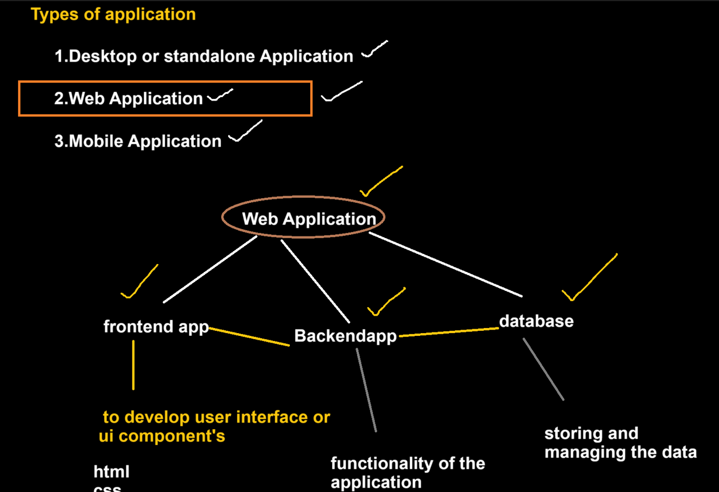
HTML

What is HTML?
HTML (HYPER TEXT MARKUP LANG) is a markup language and it’s a tag-based language.
Or
Marking up the content.
Only develop static web pages.

Why to Learn HTML and its purpose?
HTML is used to create User Interface components (collection of UI components).
Used to create Website.

HTML Document Structure
<!DOCTYPE html> (Document declaration: version of html)
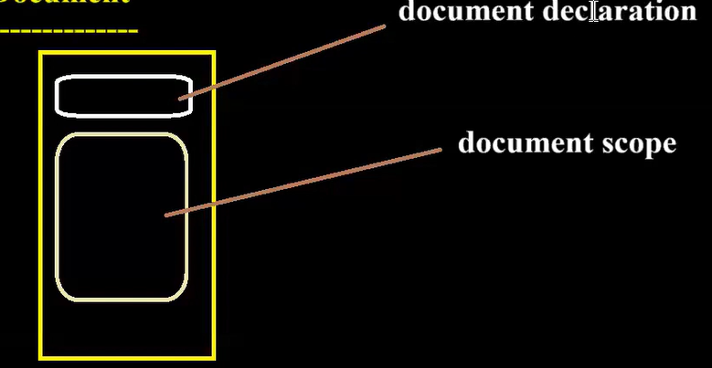
<html>
<head> “this head part only visible to the browser”
<title>Document Title</title> Title for the page
</head>
<body>
<! -- Content goes here -->
</body>
</html>
*HTML is a language used to create UI components, html will provide elements and each and every element provides some format called as tags with help of these creating UI components.

HTML Meta Tags ®:
data about data -- which is information about the HTML page itself.
Search Engine: It searches using meta tags. Without meta tags, the search engine will be unable to find or index the respective websites.
Charset
<meta charset=“utf-8”> specifies page description, keywords, copyright, language, author of the documents, etc.
Name, Content
<meta name="description" content="React Js Course">
<meta name="author" content="nothing">
Http-equiv (refresh)
<meta http-equiv="refresh" content="5000">
Viewport: website should be responsive in nature
<meta name="viewport" content="width=device-width, initial-scale=1.0">
<!-- 1.0 no zoom, 2.0 content will be zoomed -->

HTML Element?
HTML provide element to create UI components, using this element we can create UI Components.
Each and every element must have tags.
Building blocks of a web page.

HTML Tags
HTML provides some formats, those formats are called tags
○ Container tag (opening and closing tag <_> </_>)
○ Self Tag (only opening tag <_/>)
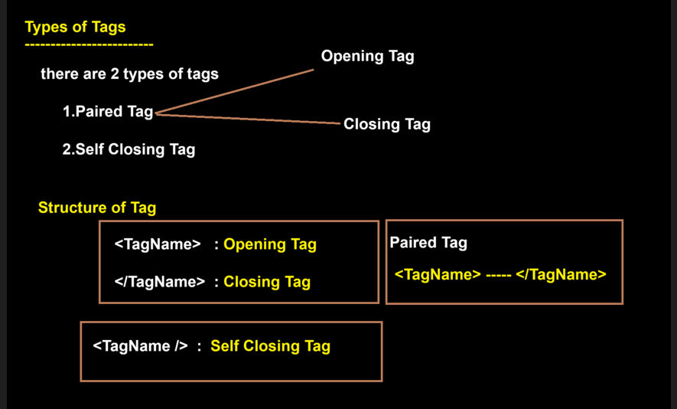

HTML Attributes
Attributes: it gives the information about the tags. (or) adding meaning to the tags
“COMMON ATTRIBUTES FOR MOST OF ELEMENTS: (Id, Class, name)”
“SPECIFIC ATTRIBUTES MENTIONED TO THE CORRESPONDING ELEMENTS: (EX: src--Source, href—hypertext reference, rel-- relationship, target, type, reverse, height, width so on…”)

HTML Comments(<!----- )

HTML Style Guide

HTML Button
<button> Button name </button>

HTML Headings
- Heading 1(<h1></h1>)
- Heading 2(<h12></h2>)
- Heading 3 (<h3></h3>)
- Heading 4(<h4></h4>)
- Heading 5(<h5></h5>)
- Heading 6(<h6></h6>)

HTML Paragraphs:
Using this element, we can add paragraph to the document.
Navigation link can achieve using this anchor element we can connect multiple web pages.
Only one tag that is “P” tag, tis paired tag.<p> Parah </p>

HTML Line Breaks
<br/> giving next line.

HTML Text Formatting Elements
- <b> and <strong> Elements: Bold and strong are like same, for whole parah we can go with strong for particular things we can go with bold
- <i> and <em> Elements: Bold and strong are like same, for whole paragraph we can go with strong for particular things we can go with bold
- <small> Element: Parah we can go with small for particular things.
- <mark> Element: highlight the Parah by default in yellow colour.
- <del> Element: Parah will be strike out.
- <ins> Element: Parah we can go with small for particular things.
- <sub> Element: Parah will be above particular things.
- <sup> Element: Parah will be below particular things.

HTML Preformatter

HTML Links & Anchor Tag
Using this element, we can create links on web page.
Navigation link can achieve using this anchor element we can connect multiple web pages.
Only one tag that is “A” tag, its paired tag
1.We can navigate to from one page to another page. —INTRA NAVIGATION
2. We can navigate from one section to other within in this same page. INTER NAVGATION.
Attributes of Anchor
- Target: where our new page needs to open here whether in same tab or new tab.
_blank: Opens in new tab.
_self: By default, it is self only so no need to mention target for anchor
_parent:
_top: Opens in new tab.
- href: The path of HTML page / WEB page where we want to navigate.
- id
- class:
example: class="hidden" that element should not visible until we write a code to display.

- name:
- title: (Link will show the title message as hint for the action we are performing)

Difference between Anchor and Link tag.
Anchor: Representation of clickable link.
Link: linking of external CSS sheets, but not a clickable link
<link rel="stylesheet" href="styles.css">-adding css file
The anchor element, also known as the "link" element, is a fundamental HTML element that
allows you to create hyperlinks on web pages. When a user clicks on an anchor element, they
are redirected to a new web page or a specific section of the same page.
The basic syntax of the anchor element looks like this:
Here, "href" is an attribute that specifies the URL or destination of the link, and "Link text" is the
text that appears as the link on the web page.
There are several other attributes you can use with the anchor element to enhance its
functionality and appearance. Some of the most commonly used attributes are:
target: This attribute specifies where the linked document will open. Possible values are _self
(default, opens in the same window/tab), _blank (opens in a new window/tab), _parent (opens in
the parent frame), and _top (opens in the top-level browsing context).
title: This attribute adds a tooltip to the link that appears when the user hovers over it. The
tooltip can provide additional information about the link or its destination.
rel: This attribute specifies the relationship between the current document and the linked
document. Possible values are noopener (prevents the linked page from controlling the current
page), noreferrer (prevents the browser from sending a referrer header to the linked page), and
nofollow (tells search engines not to follow the link for ranking purposes).
download: This attribute specifies that the linked document should be downloaded instead of
displayed in the browser when clicked. The value of the attribute is the suggested filename for
the downloaded file.
Here's an example that uses several of these attributes:
This anchor element opens "https://example.com" in a new tab/window when clicked, displays a
tooltip with the text "Go to Example.com" when hovered over, and includes the noopener and
noreferrer attributes to enhance security.
Intra navigation, also known as internal linking, is the practice of linking to other pages or
sections within the same website. This can be accomplished using the anchor element in HTML.
To create a link to a specific section within the same page, you can use the id attribute to
identify the section, and then use the href attribute to link to it. Here's an example:
In this example, we have two sections on the same page, each identified by an id attribute. We
then create two anchor elements that link to these sections using the href attribute and the
corresponding id values.
When the user clicks on one of these links, the browser will scroll to the specified section on the
same page. This can be useful for creating a table of contents or navigating between different
sections of a long article or web page.
Inter navigation, also known as external linking, is the practice of linking to pages or websites
outside of your own website.
This can be accomplished using the anchor element in HTML.
To create a link to an external website, you can use the href attribute to specify the URL of the
website. Here's an example:
In this example, we create an anchor element that links to "https://www.example.com". When
the user clicks on this link, they will be taken to the specified website in a new tab or window
(depending on the value of the target attribute).
It's important to note that when linking to external websites, you should use the rel="noopener
noreferrer" attribute to enhance security. This attribute prevents the external website from being
able to control the linking page, which can help prevent phishing attacks and other security
risks.
Here's an example of an external link with the rel attribute:
In this example, we've also used the target="_blank" attribute to open the link in a new tab or
window.

HTML DIV
Used to create section/layout(rows & columns) on the web page(Flex/Grid in CSS)
Used to group multiple elements, it is a plain element by default in HTML.
It provides only one tag called <div> </div> and it is paired tag.
We don’t have any explicit attributes for div elements.
By default no styles will be added.
- Section:
- Layout: It uses rows and columns, which can be achieved using FLEX or GRID from CSS.

HTML Images
It’s a self-closing tag <img />
- Src
<img src="path/to/image.jpg" alt="description"> linking images
<script src="path/to/your-file.js"></script> linking external JavaScript
- Alt
- Width
- height

HTML Image Links

HTML Tables
Tables are often used to organize data or display information in a tabular format.
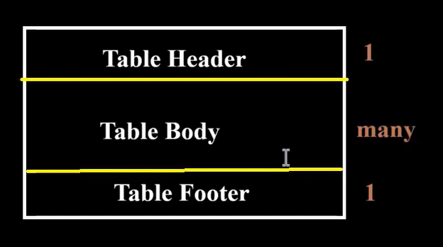
- thead
- tbody
- tfoot
- tr
- th
- td
- Colspan
- Rowspan
- Table fully styles
- Nested Table in HTML
Attributes of table:
Frame:
above, below, box, lhs, rhs
Rules:
all, groups, rows, cols
border: This attribute specifies the width of the border around the table. The default value is 0, which means no border.
cellpadding: This attribute specifies the padding within each table cell. The value is measured in pixels.
cellspacing: This attribute specifies the space between table cells. The value is measured in pixels.
width: This attribute specifies the width of the table. The value can be a percentage or a pixel value.
height: This attribute specifies the height of the table. The value can be a percentage or a pixel value.
align: This attribute/properties specifies the horizontal alignment of the table within its containing element. The possible values are "left", "center", or "right".
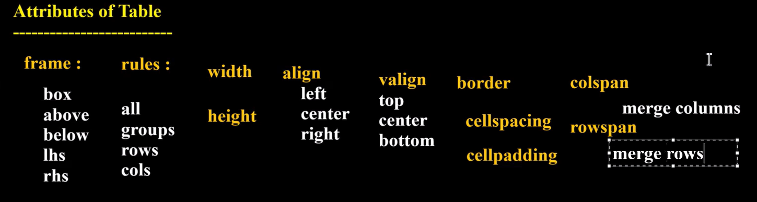

HTML Lists
- Unordered HTML List: Used to show content in ordered list format

- Unordered Nested
- Ordered HTML List: Used to display content in list format
<ol>
<li></li>
</ol>
--- can have any number of li inside this ol, li is sub element
- Ordered Nested
- Description Lists
HTML Block and Inline Elements:
Block
Inline: span, strong, image, input are inline element, it will print in the same line and unable to change width and height except image.
Note: display: inline; is only needed if you were not using flex.

HTML class Attribute

HTML id Attribute

HTML Iframes :
- it is paired tag
- A way to embed another HTML document into the current document. It is commonly used to include content from other websites, such as a video, a map, or a social media widget.
- Don’t have any kind of children.
list of attributes that can be used with the element:
src: This attribute specifies the URL of the document to be embedded.
<iframe src ="http://www.example.com"></iframe>
width: This attribute specifies the width of the iframe. The value can be specified as a positive integer followed by a unit of measurement, such as "px" or "em".
<iframe src="http://www.example.com" width="500px"></iframe>
height: This attribute specifies the height of the iframe. The value can be specified as a positive integer followed by a unit of measurement, such as "px" or "em".
<iframe src="http://www.example.com" height="300px"></iframe>
name: This attribute specifies a name for the iframe. This name can be used as the target of links, form submissions, and JavaScript functions.
<iframe src="http://www.example.com" name="myframe"></iframe>
frameborder: This attribute specifies whether or not the iframe should have a border. The value can be "0" or "1".
<iframe src="http://www.example.com" frameborder="0"></iframe>
scrolling: This attribute specifies whether or not the iframe should have scrollbars. The value can be "yes", "no", or "auto".
<iframe src="http://www.example.com" scrolling="auto"></iframe>
allowfullscreen: This attribute specifies whether or not the iframe should be allowed to enter fullscreen mode. The value can be "true" or "false".
<iframe src="http://www.example.com" allowfullscreen="true"></iframe>
allow: This attribute specifies a space-separated list of features that the iframe is allowed to use. Example:
<iframe src="http://www.example.com" allow="camera; microphone"></iframe>

HTML Computer Code Elements ®
- <code> for Code Elements
- <kbd> For Keyboard Input
- <samp> For Program Output

HTML Semantic Elements / Tags
- <header> Element
- <footer> Element
- <nav> Element
- <section> Element
- <article> Element
- <aside> Element

HTML Marquees
it is paired tag
it is used to add scrolling effect on the text.
- Direction
- Behavior
- Scrolldelay
- Scrollamount
- Loop etc..

HTML Forms
It is a paired tag, using form with sub elements can create form in UI.
LOGIN form, SIGNIN form, QUIZ form, FEEDBACK form.
Form are used to take the data from users.
- Form Elements
- Form Attributes
- Input Types: self-closing tag, can accept lot of attributes.
- Placeholder
- Text Input Controls
- Checkboxes Controls
- Radio Box Controls
- Select Box Controls
- File Select boxes
- Hidden Controls
- Textarea
- Submit and Reset Button
- Autocomplete
- Required
- Disabled
- minlength and maxlength etc..

HTML New Input Type
- color
- Number
- Range
- Date
- Datetime-local
- Month
- Week
- Time
- Email
- Search
- Url
- Image

HTML Progress Tag:
Completion progress length

HTML Media
Video
- Source
- Autoplay: currently not in use.
- Controls
- Loop
- Muted
- Src
- Poster
Audio
- Source
- Autoplay: currently not in use.
- Controls
- Loop
- Muted
- Src

HTML CSS

ELEMENTS PROPERTY

TAGS Key:Value

UI Components Style to UI component

CSS

What is CSS?
CSS(Cascading Style Sheet) is a styling language.

Why to Learn CSS or Use of CSS?
Designing our UI components or styling our UI components.
Used to add/change the style or design to the UI component or HTML elements.

Advantages of CSS
Provides set of or collections of Properties, using this we can style up UI components.
Every properties will give style/designs.

CSS Selectors
- Simple selectors
- Combinator selectors: Here elements are selected using relationship.
- Descendant: parent element( parent space Element)
Example: container p{ color:red }
All p tag avail under that selector will apply .
- Adjacent relationship
Example: div + p{ color:red }
Only for the first p tag avail under that div will apply .

- Child: only direct child element will get its style.
Example: container > p{ color:red }
All p tag avail under that selector will apply .

- General sibling
Example: container ~ p{ color:red }
Only for all siblings of p tag avail under that div will apply .
Note: not for grand siblings

- Attribute selectors

STEPS To Add CSS:
Select the element which you need to style it, we can select element in two ways.
SYNTAX
Tag Name or Id Value {
CSS PROPERTIES
}

How To Add CSS
- External CSS
- Internal CSS
- Inline CSS

CSS Colors
Using CSS color property we can change the color of the html element.
- RGB Colors
- HEX Colors
- HSL Colors
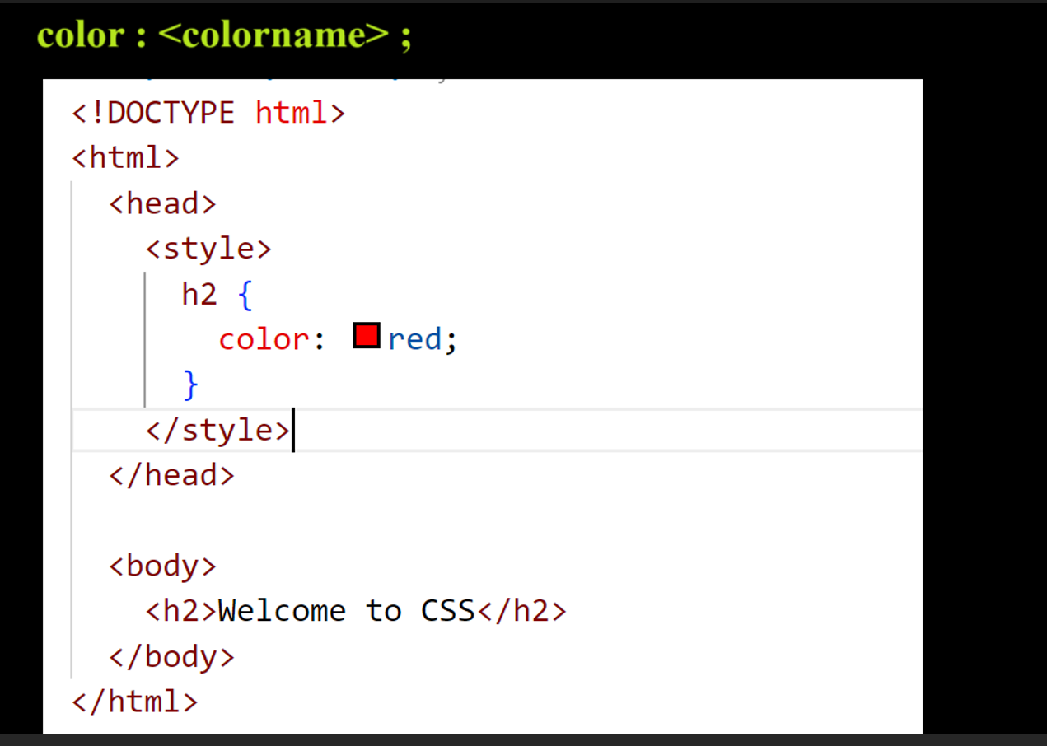

CSS Backgrounds:
This property sets the background color of an HTML element. You can specify the colour using a colour keyword, a hexadecimal value, hsl.
Example: background-color: <ColorName>
- body {background-color: coral;}
- body {background-color: #92a8d1;}
- body {background-color: rgb(201, 76, 76);}
- body {background-color: hsl(89, 43%, 51%);}
background-repeat: no-repeat;
background-position:12px, 7px(denotes x-axis, y-axis)
background-position:12px, 7px(have top, bottom, right, left options also)
background-size:
background-attachment: (scrolling, fixed)

CSS Fonts Style ®
- font-family
- font-style
- font-weight
- font-size
- font

CSS Text:
- color
Used to color the HTML element.
P {
Color: blue;
}
- direction
Usually converts text into alternate direction.
Right to left and right to left
Ex: style = “direction: ltr”
Ex: style = “direction: rtl”
- text-align
- text-decoration
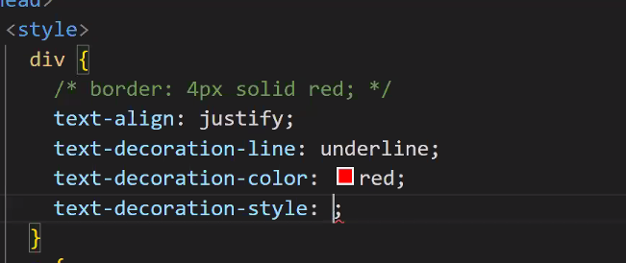
- text-transform:
Usually converts text into upper case or lower case or capitalise format.
Values are:
- uppercase
- lowercase
- capitalize
Ex: text-transform: uppercase
- word-space
Used to generate space between the word.
Ex: word-spacing: 20px;
- letter-spacing
Used to generate space between the letter.
Ex: letter-spacing: 10px;
- white-spacing
- text-shadow
Used to add Shadow to the text.
Values are:
- h-space v-space blur color
Ex: text-shadow: 50px 60px 2px red;

- text-indent
Used to generate indentation for the first line of your paragraph
Ex: text-indent: 50px;

CSS Box Model
CSS Borders
Add border(property) to HTML element, to add border need to define width, style, color.
- border-style: solid, dotted, dashed, double.
- border-width
- border-color
If use pixel it won’t depend on anything, If use percentage (%) div will depend on body.
1inch = 96 pixels
1px = 0.03cm
1cm=38px

CSS Margins:
Margin property is used to create space around an HTML element.
Margins are the empty spaces between the element's border and the adjacent elements or space outside the border.
Values are applied on clock wise direction.
Margin: auto (equal space from left and right, exactly center)
- margin-top
- margin-right
- margin-bottom
- margin-left
CSS Padding: it use to generate space between border and content of the element (or) used to generate space inside the border.
- padding-left
- padding-right
- padding-bottom
- padding-top
- padding
CSS Width
- max-width
- min-width
CSS Height
- max-height
- min-height

CSS Links Style ®
- :link
- :visited
- :hover
- :active

CSS Outline
- outline-width
- outline-style
- outline-color
- outline-offset
- Outline

CSS Display Property
- inline
- inline-block
- block

CSS Float Property

CSS Clear Property

CSS Cursors Style

CSS Overflow Property
- overflow-x
- overflow-y
- overflow

CSS Position Property
- Static
- Absolute
- Relative
- Fixed
- Sticky
Difference between position layout none and position absolute?
Absolute: related to nearest positioned ancestor or initial containing block.
Relative: related to normal position in the document.

CSS Z-index Property

CSS Combinators
- descendant selector (space)
- child selector (>)
- adjacent sibling selector (+)
- general sibling selector (~)

CSS !important Rule

CSS Units ®
- (em,rem,vh, vw,vmax,vmin ,px,%)

CSS Pseudo Classes ®
- :link
- :visited
- :hover
- :active
- :focus
- :focus-within
- :enabled
- :disabled
- :checked
- :required
- :read-only / :read-write
- :root
- :first-child
- :last-child
- :nth-child()
- :nth-of-type()
- :first-of-type
- :last-of-type
- :nth-last-of-type()
- :nth-last-child()
- :only-of-type
- :empty
- ::first-letter
- ::first-line
- ::marker (UL/OL List)
- ::selection

Difference between display none and visibility hidden

CSS Rounded Corners
- border-top-left-radius
- border-top-right-radius
- border-bottom-right-radius
- border-bottom-left-radius
- border-radius

CSS Gradients

CSS Accent-Color

CSS filter Property

CSS Media Types (Responsive)
- @media print
- @media screen

CSS Shadow Effects
- Text Shadow
- Box Shadow

CSS 2D Transforms:
- translate() Method
- rotate() Method
- scale() Method
- skew() Method

CSS 3D Transforms
- rotateX() Method
- rotateY() Method
- rotateZ() Method

CSS Transitions
- transition
- transition-delay
- transition-duration
- transition-property
- transition-timing-function

CSS Animations
- @keyframes
- animation-name
- animation-duration
- animation-delay
- animation-iteration-count
- animation-direction
- animation-timing-function
- animation-fill-mode
- Animation

CSS Flexbox
Flex is used to create layout for the web page in one direction.
We can create layout in horizontal or vertical direction, we can create only one direction at a time.
LAYOUT: arranging the elements in a row or column is called layout.
Body or parent element as flex container.
Body{ display:flex; }-Direct child will act as flex container of that element.
Example:
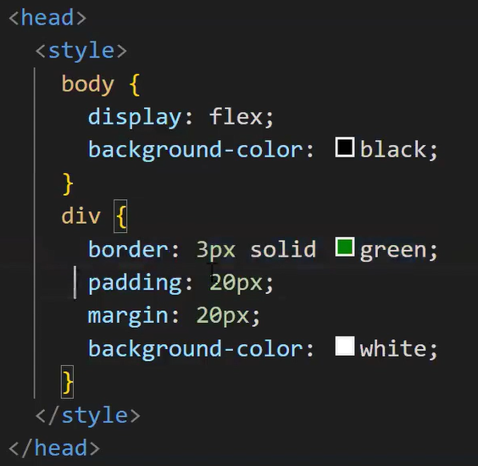
Default direction of the flex in flex container is row so the flex items will display left to right.
row-direction | column-direction
Flex items will display in horizontal direction or x-axis line. | Flex items will display in vertical direction or y-axis line.
flex-direction
It specifies the direction of flex item.
- flex-direction: column
The display will be in column direction after flex-direction property is used.
- flex-direction: row-reverse
The flex items will display in row but from right to left.
- flex-direction: column-reverse
The flex items will display in row but from bottom to top.
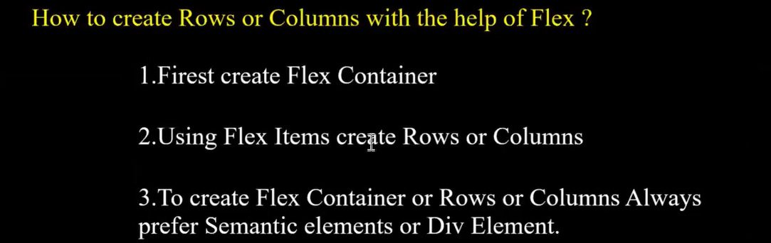

CREATING A FLEX IN COLUMN DIRECTION:
In style tag
<style>
display: flex;
flex-direction: column;
</style>
- flex-wrap
- flex-flow
- justify-content
- align-items
- align-content, order
- Grid
- Grid Template Columns
- Grid Template Rows
Difference between CSS FLEX and CSS GRID.?
FLEX: One dimensional layout, ideal for single row or column.
GRID: Two-dimensional, complex layout.
GRID in CSS
In CSS, a grid is a layout system that allows you to create complex and flexible layouts for your
web pages. It works by dividing a web page into a grid of rows and columns, and then placing
content within those rows and columns.
The CSS Grid layout provides two-dimensional layout control, where you can place items in
rows and columns. It allows you to create a grid container, which is the parent element that
holds the grid items (child elements).
To Create Grid Container use the Following Property
display : grid
The grid-template-columns property in CSS Grid layout is used to define the columns of a
grid. It specifies the size, shape, and number of columns in a grid container.
The grid-template-columns property can take one or more values, which specify the size of each
column. You can use various units like pixels, percentages, em, rem, auto, and fractional units
(like fr) to define the size of the columns. Here's an example that creates a grid with three
columns of equal width:
In this example, the grid-template-columns property has three values, each with a value of 1fr.
The fr unit is a fractional unit that divides the available space among the columns. In this case,
the available space is divided into three equal parts.
In this example, the first column is set to a fixed width of 200px, while the second and third
columns are set to take up one-third and two-thirds of the remaining space, respectively.
In addition to setting the size of columns, you can also use the grid-template-columns property
to define the number and position of grid lines, which can be used to position grid items within
the grid.
The grid-template-rows property in CSS Grid layout is used to define the rows of a grid. It
specifies the size, shape, and number of rows in a grid container.
The grid-template-rows property can take one or more values, which specify the size of each
row. You can use various units like pixels, percentages, em, rem, auto, and fractional units (like
fr) to define the size of the rows. Here's an example that creates a grid with three rows of equal
height:
In this example, the grid-template-rows property has three values, each with a value of 1fr. Like
with grid-template-columns, the fr unit is a fractional unit that divides the available space among
the rows. In this case, the available space is divided into three equal parts.
You can also use other units and values in combination with the fr unit to create more complex
layouts. For example:
In this example, the first row is set to a fixed height of 200px, while the second and third rows
are set to take up one-third and two-thirds of the remaining space, respectively.
In addition to setting the size of rows, you can also use the grid-template-rows property to define
the number and position of grid lines, which can be used to position grid items within the grid.

BOOTSTRAP

Introduction to Bootstrap? and its Features

Bootstrap Installation

Setting Development Environment

Grid System

Components
- Basic Typography
- Text Alignment & Display
- Colors Background:
- Buttons
- Navbars
- List groups
- Badges
- Forms
- Carousel
- Modal
- Table
- Cards
- Pagination
JAVASCRIPT

Javascript?
Javascript is object-based scripting language or programming language and also client side scripting language
it is line by line execution (synchronous execution).
Each and every browser will have its own javascript engine.
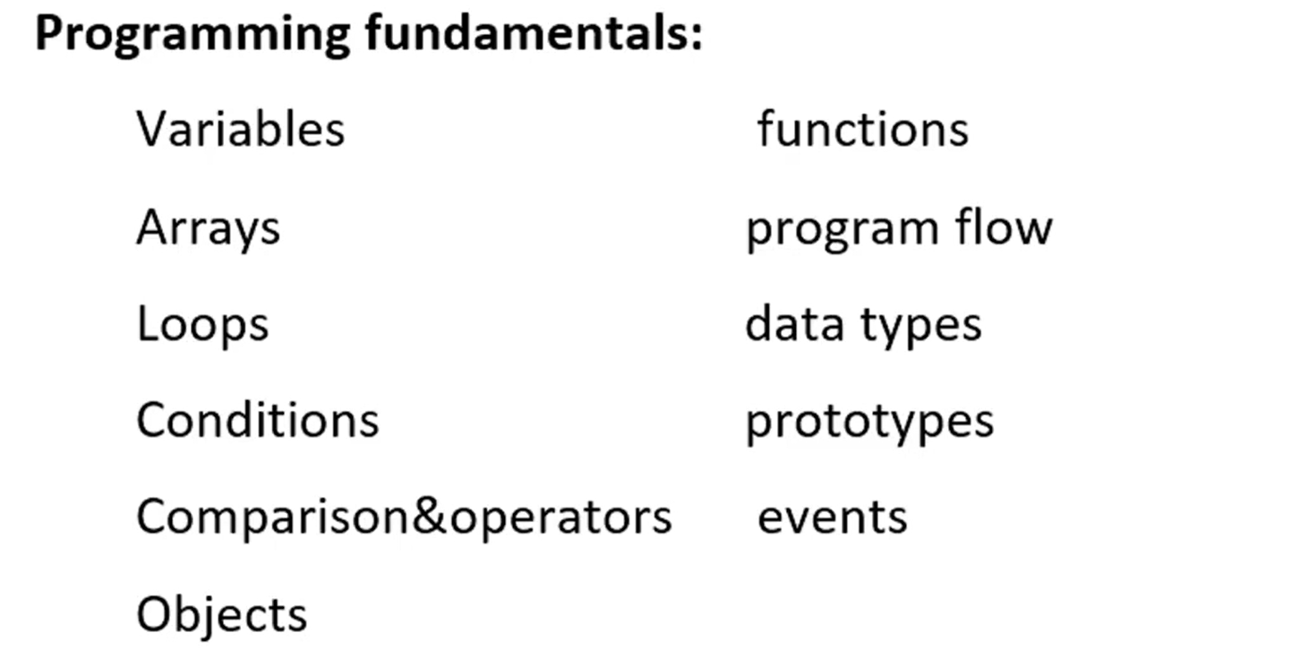

Purpose of Javascript?
Creating interactive pages.

Ways to write Javascript?
<script> </script> (Inside of script tag)
External file and then include as a part of script file.
src=””

Best place to write Javascript code?
At body part: Once the HTML elements are loaded, the script should load afterwards. If the script refers to any of the elements, it should not throw an error.

Debugging in Javascript
1. console.log()
console.assert(exp ,message); //only error occurs it will be printed
2. debugger; // keyword used to stop execution
3. Browser breakpoint
4. Conditional Breakpoint
Right Click => Add a conditional break point

Variables and datatypes in Javascript
Variables are named storage of data or Variables are used to store the information.
1. Variable name should contain only letter,digits,symbols($) and (_)underscore
2. First character must not be the digits
3. Variable Names should be in camelCase
4. Variable Names are Case Sensitive
5. Should not use keywords/reserved words
Datatypes.
Data type used to store single value are known as Primitive data types
1. Number type
let n = 123 ;
let m = 123.45;
typeof n => number , typeof m => number
typeof typeof n => string
2. BigInt
2^53-1 and -(2^53-1) this is a range bound
limitations of number
let n = 78654341234724313465564545n;
3.string
let a = "hello";
let b = 'hello';
let c = `hello`; //template string literal
4. Boolean
true or false
if(10>1){ }
5. undefined: In javascript you declare a variable and not assign any value then it will hold undefined it.
let a;
console.log(a);
6. null: in javascript null means "reference to non-existing object " –( The garbage collector frees up memory by removing objects that are no longer accessible in the program.)
let a = null;
typeof a => object
Data types are used to store multiple values are known as Non-Primitive Data types
Object, Arrays
Objects => collection of various data types, store key value pair so it can store multiple values and keys are always string.
There are 2 ways to declare an object.
- object constructor syntax…its quite difficult
let user = new Object;
- Object notation or Json Notation (JavaScript object notation)
let user = {
“name” : “jhana”,
“age”: 32
}
Hint: Reserved words (keywords) cannot be used as variable names, but they can be used as object keys.
We can change the property value of an object because it is passed by reference, not by value.
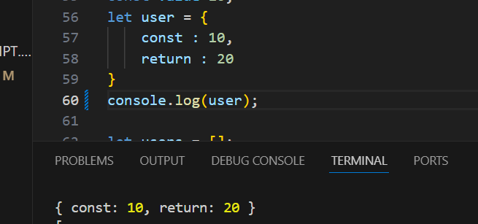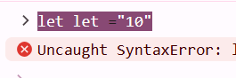
There are two ways to access an object’s properties: dot notation and bracket notation.
If the key has spaces, special characters we have go for bracket notation [].

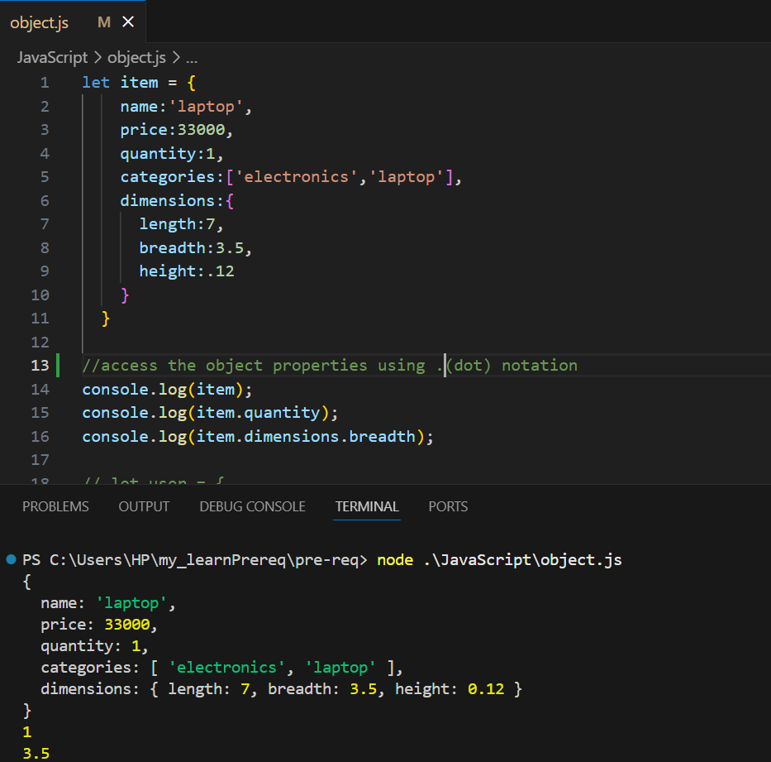

Add a property to the object
objectName.newKey = value
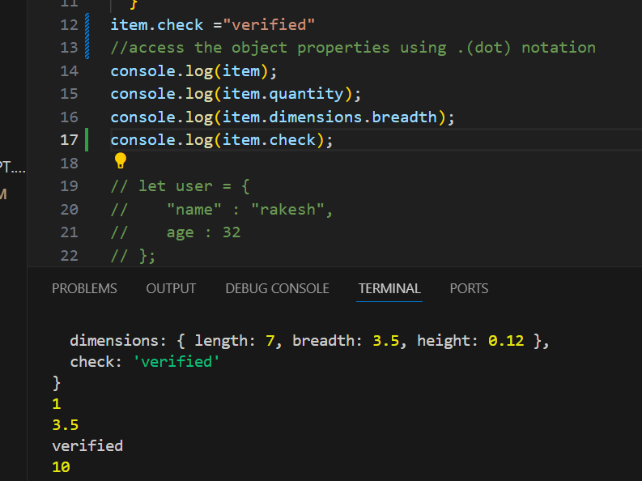
Modify property from the object
Hint: Even we can modify the property value but not the key.
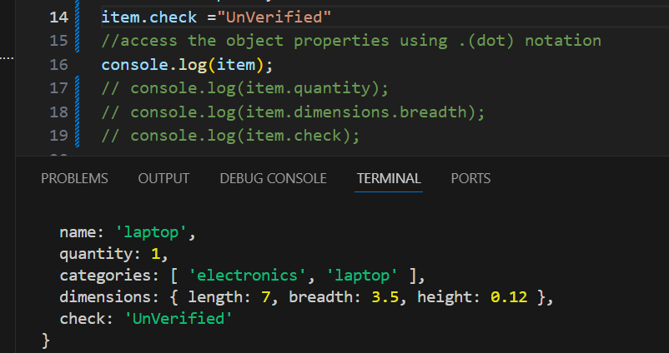
Delete property from the object
Hint: Yes, deleting a property from an object is possible, but deleting a variable is not.
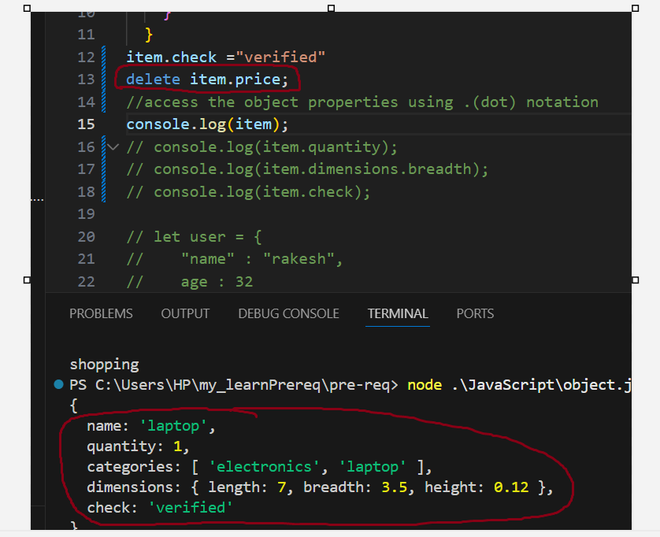
Hint: If you try to access a variable or an object property that doesn't exist, it will return undefined.
Arrays: Collection of element or ordered collection of elements.
There are 2 ways to declare an array.
- ler arr = new Array(); //not much preferred way
- let arr = {};
Arrays in JavaScript are index-based. If you assign a value to a non-existing index, it will be added to the array. If you assign a value to an existing index, it will replace the current value.
Array methods: push(), pop(), shift(), unshift(), slice(), splice(), find(), indexOf(), forEach(), filter(), map(), includes(), sort(), reverse(), reduce(), concat(), join(), flat()
push and pop will act on end of the array. (add and remove at end)
shift, unshift will act on start of the array. (add and remove at start)
slice return a part of the array (does not modify original)
splice adds/removes elements (modifies original array)
find returns the first element that matches a condition
indexOf returns the index of a value (-1 if not found)
forEach loops through the array (no return value)
filter returns a new array with elements that match a condition
map transforms each element and returns a new array
includes checks if a value exists in the array
sort sorts the array (as strings by default)
reverse reverses the array order
reduce reduces array to a single value
concat merges arrays
join joins elements into a string
flat flattens nested arrays
Hint: Array Length Greatest Numerical Index + 1;
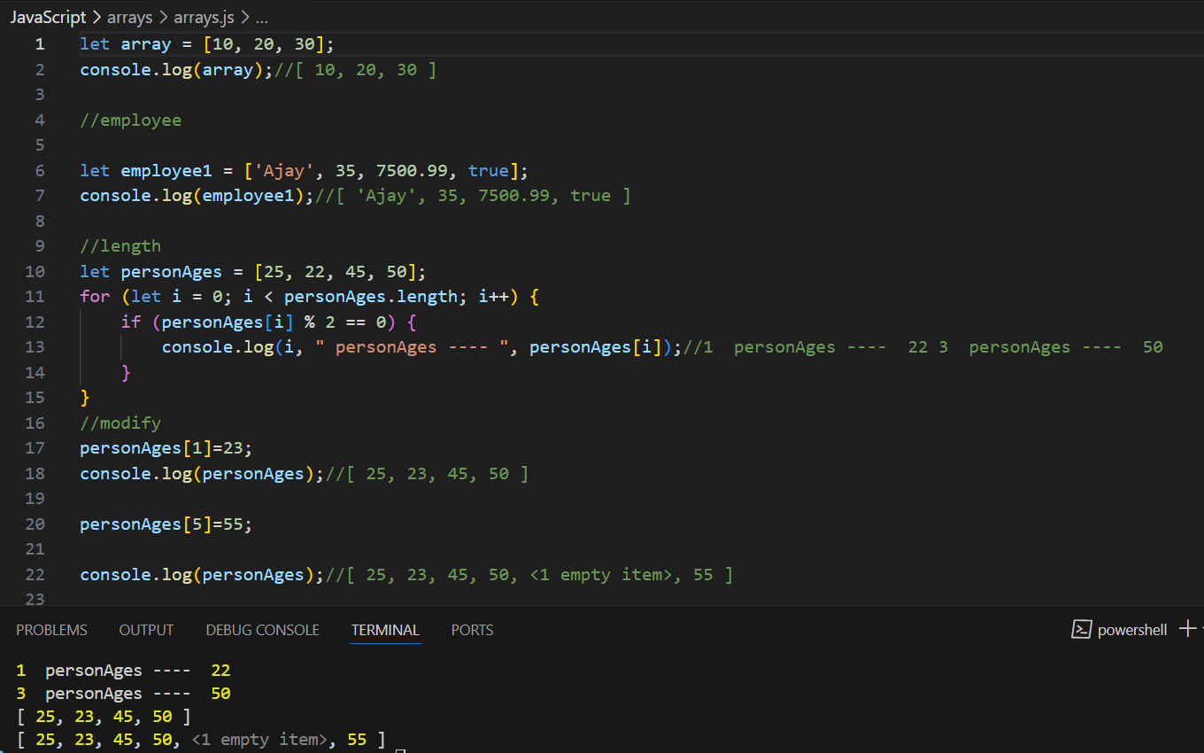

Map?
When you want to iterate over each and every element perform some computation or some transformation.
map always return new array by performing action on original array.
Example: const number = [2,4,6,8];
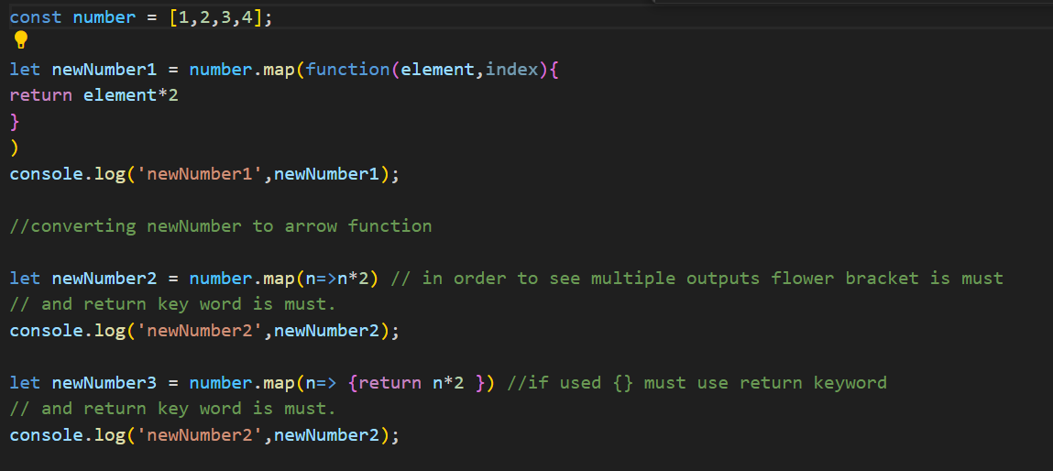
Another Example:
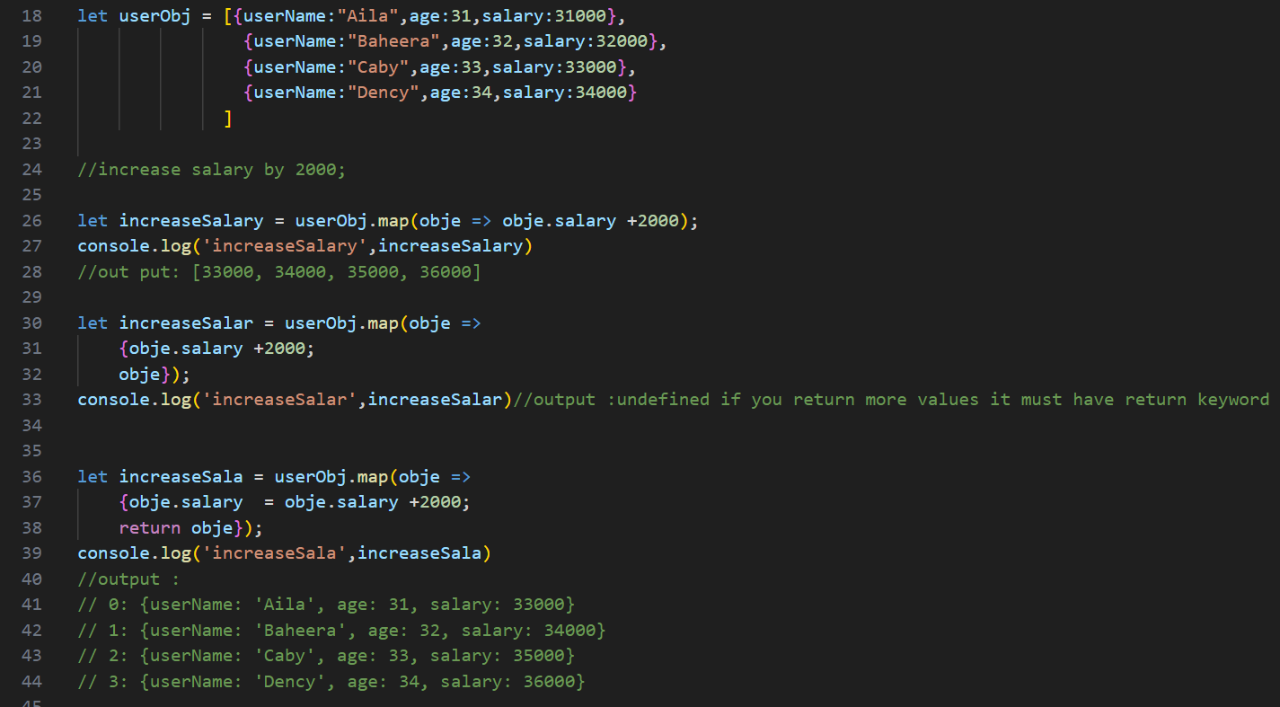
Note: if you return more values, it must have return keyword in flower braces.

Filter?
Need to filter based on Conditional based.
Act on Each and every element with condition.
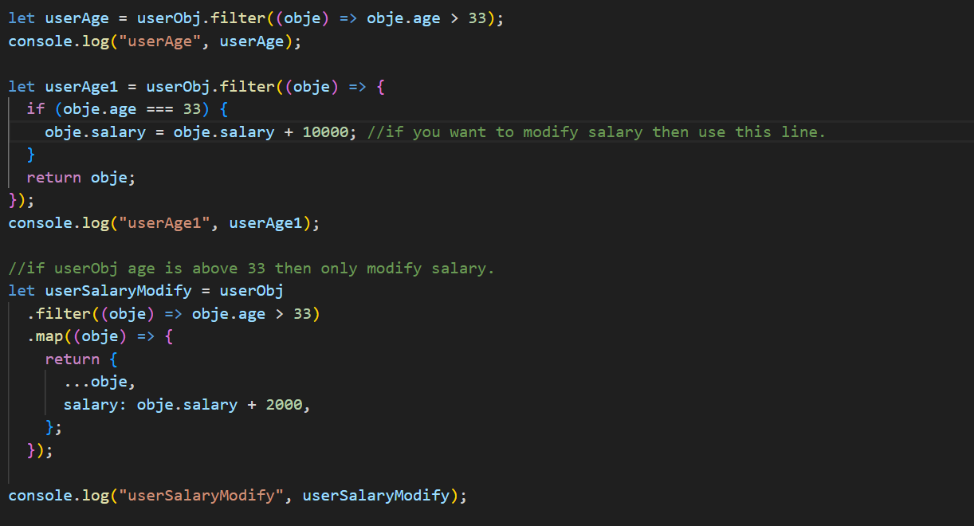
Another example
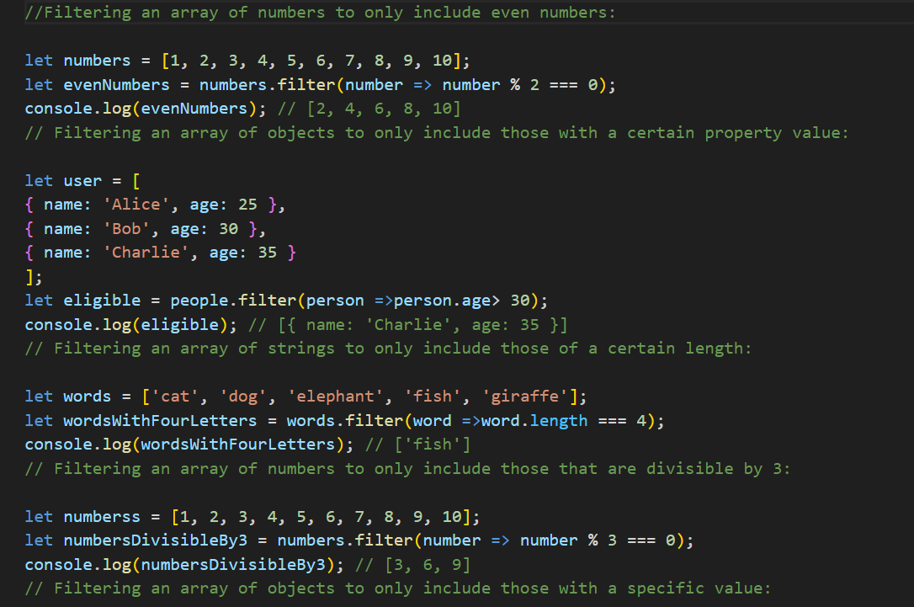
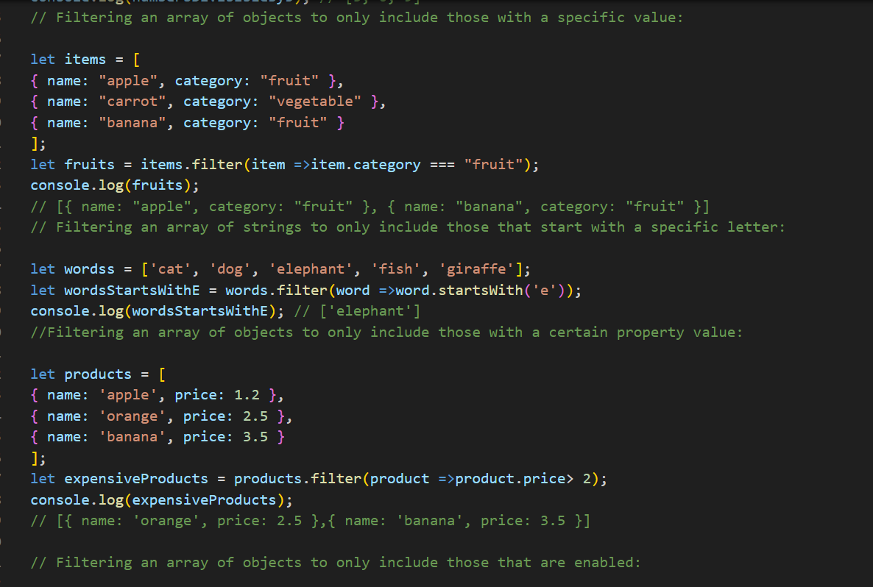

Function
Functions are building blocks, allow not to repeat the code. (Runs Only when you call it)
Parameters → Variables in the function definition.
Arguments → Values passed to the function when calling it.
Two types: Function Declaration and Function Expression
Function Declaration
supports hoisting.
a named function using the function keyword.
Function Expression
doesn’t support hoisting.
defines a function and assigns it to a variable

Conditional Statements?
execute different code blocks based on certain conditions (true/false).
If, if else, if elseif else:
drawback of multiple elseif condition is Poor Readability, Hard to Maintain, Performance (in some cases), Not Scalable.
Switch: Used to select one of many code blocks to be executed.
Ternary Operator: (condition ? expr1 : expr2) is a concise way to write an if-else statement in a single line.
condition ? trueBlock : falseBlock;
let num = 13;
let result = num % 2 == 0 ? "even" : "odd";
console.log(result); // Output: "odd"

Loops?
Loops are way to repeat the same code number of times Until condition is false.
Iteration: Execute a definite number of times.
Initialization, condition, inc/dec
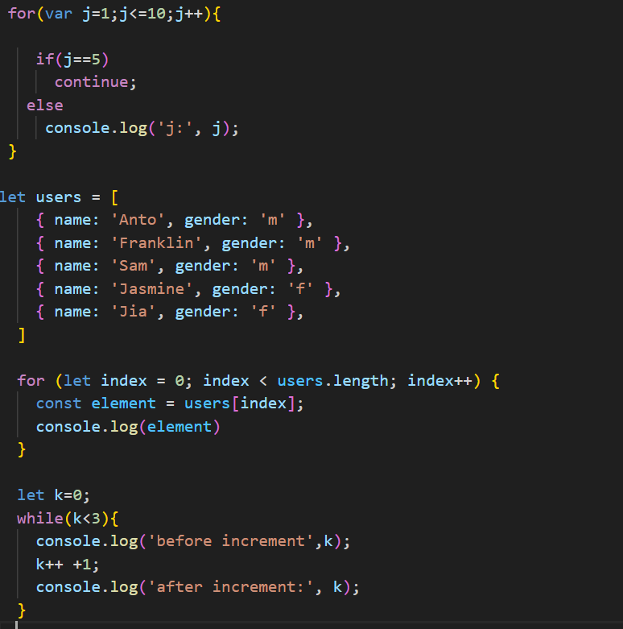
FOR IN & FOR OF
FOROF is used to iterate over iterable object.
FORIN is used to iterate over the enumerable properties (keys) of an object—( technically be used on arrays)
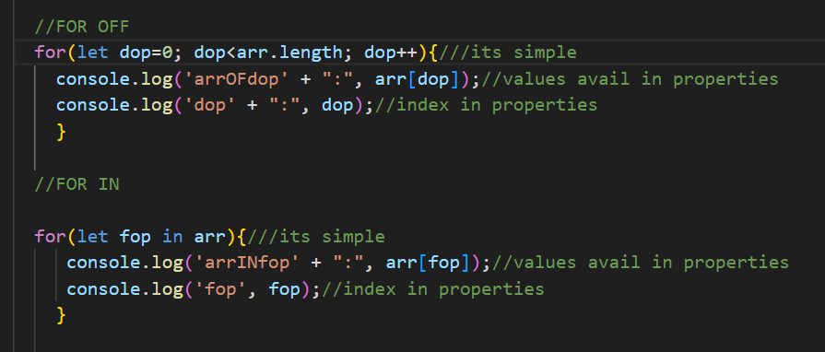
Hint: Falsy values in JavaScript: 0, NaN, undefined, false

Difference between VAR, LET, CONS
var, let, and const are used to declare variables. However, they differ in behaviour with respect to the following three key concepts:
HINT: ES6 let and const were introduced to reduce the bugs at run time
1.Hoisting: It moves variable/function declaration to the top of its nearest scope.
2. Scope and Memory Handling:
3. Redeclaration and Reassignment:
Var | Let | Const
console.log(a); | HOISTING will not support
var a = 10;
Internally var a; console.log(a);//nearest scope a = 10 ;
SCOPE/Memory var is a function level scope.  var scope will be available throughout the function | let/const are block level scope { }.  It will be available within the block
var supports redeclaration and Updation | let supports only Updation but does not allow redeclaration. | const, neither redeclaration nor Updation is allowed, so it must be initialized with a value at the time of declaration.

With const objects, the properties can be updated, but the entire object cannot be reassigned.
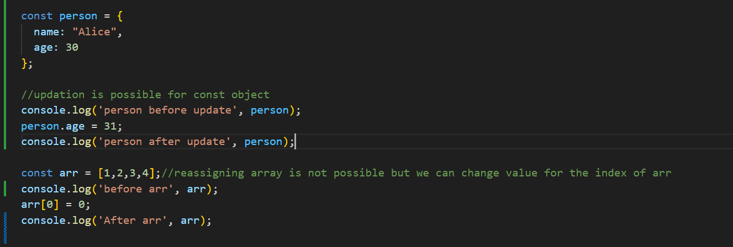
With a const array, you can modify the contents (like add, remove, or update elements), but you cannot reassign the entire array to a new one because its reference (memory address) is constant.

Destructuring of Objects and Arrays?
To extract values from arrays or properties from objects and assign them to variables.
Points to Remember:
- Destructuring helps avoid repetitive dot notation (ObjectName.PropertyName).
- Variable name must match the key name when destructuring the object.
- You can assign default values to avoid undefined for missing properties.
- Default values apply only to keys not present in the object.
Note: While destructuring, we can provide default values, but those default values do not become part of the original object or array.
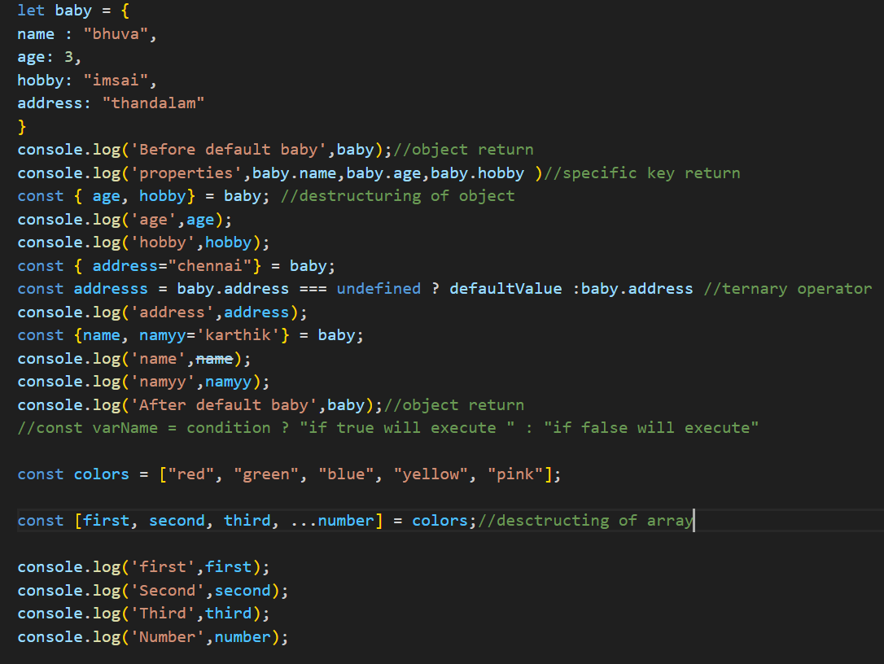
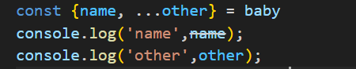
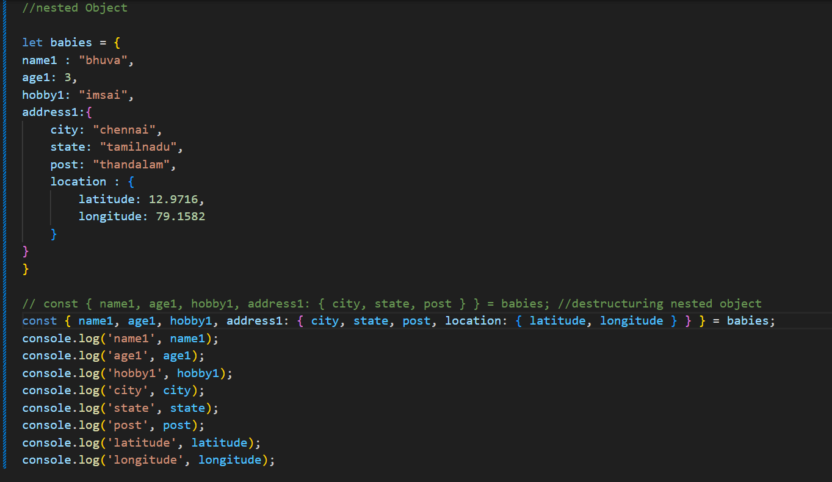

Optional Chaining?
Optional chaining (?.) helps write error-free code by safely accessing nested object properties.
It will return undefined instead of throwing an error.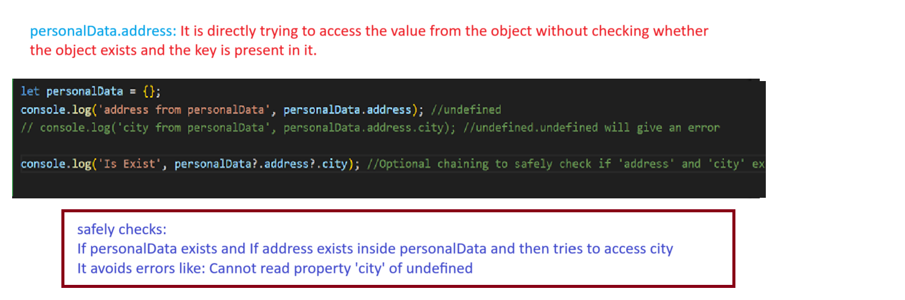

Arrow Function?
arrow function is a simplified code, or reduce of lines.
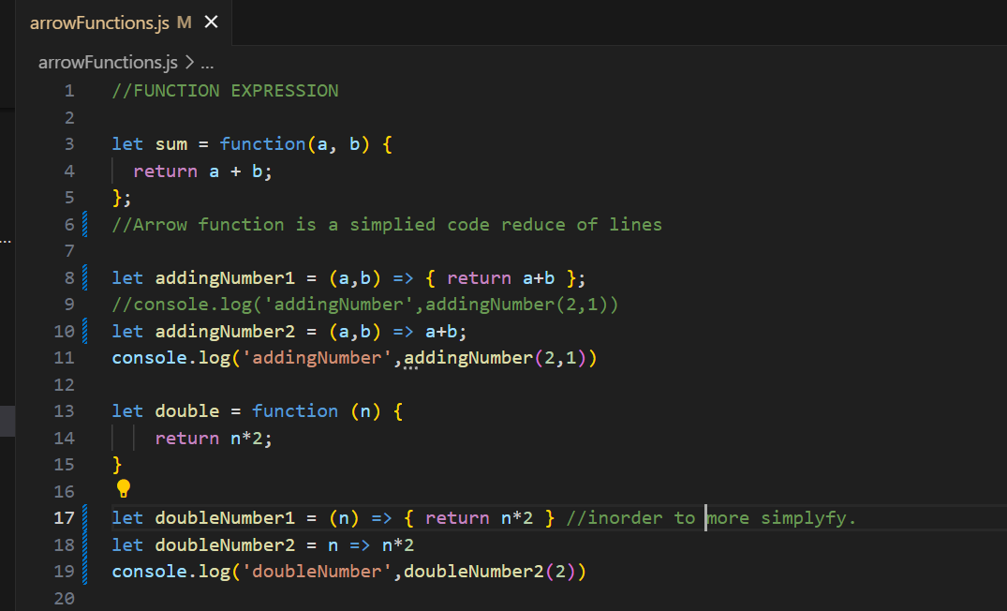

SCOPE:
Local Scope: { inside Curly braces } limited
Global Scope: It is accessible to all over the program

Call Backs?
Certainly! A callback function in JavaScript is a function that is passed into another function as an argument to be executed later.
Used to achieve asynchronous way of programming.
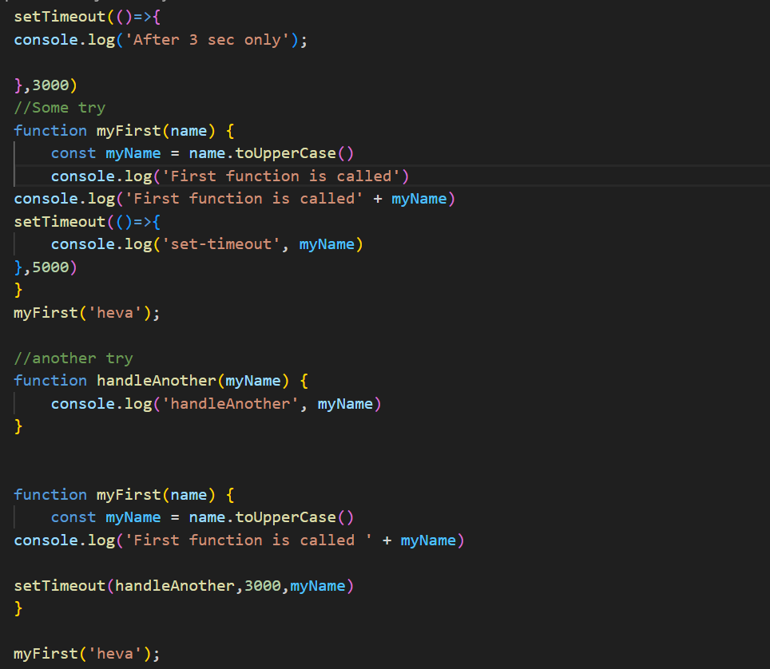

Import & Export?
- ES6 concepts
We can achieve reusable concepts using Import & Exports concept.
export is used to expose a module's functionality—like functions, variables, or classes—so they can be imported and used in another JavaScript file. Similarly, import is used to bring in exported items from other modules.

